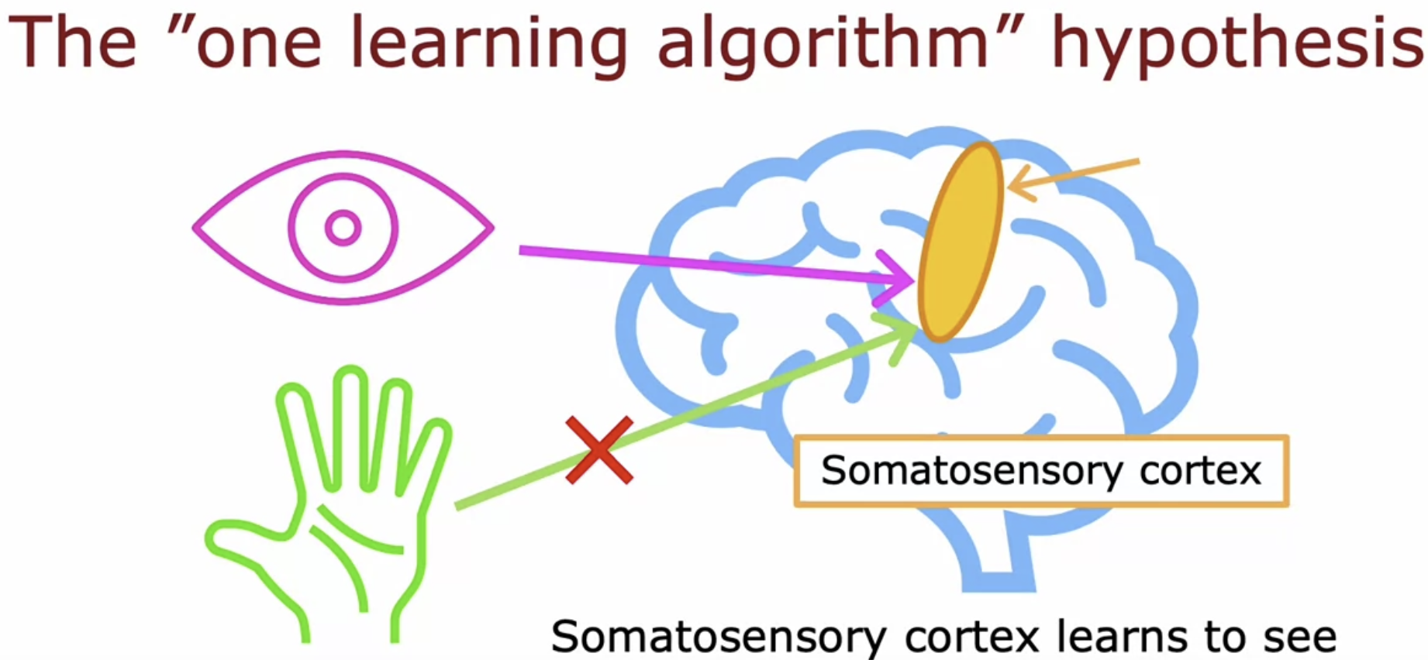

There's been a sequence of experiments like this, showing that many different parts of the brain, just depending on what data is given can learn to see, or learn to feel, or learn to hear as if there was maybe one algorithm that just depending on what data or this given, learns to process that inputs accordingly.

# **How neural networks are implemented efficiently**

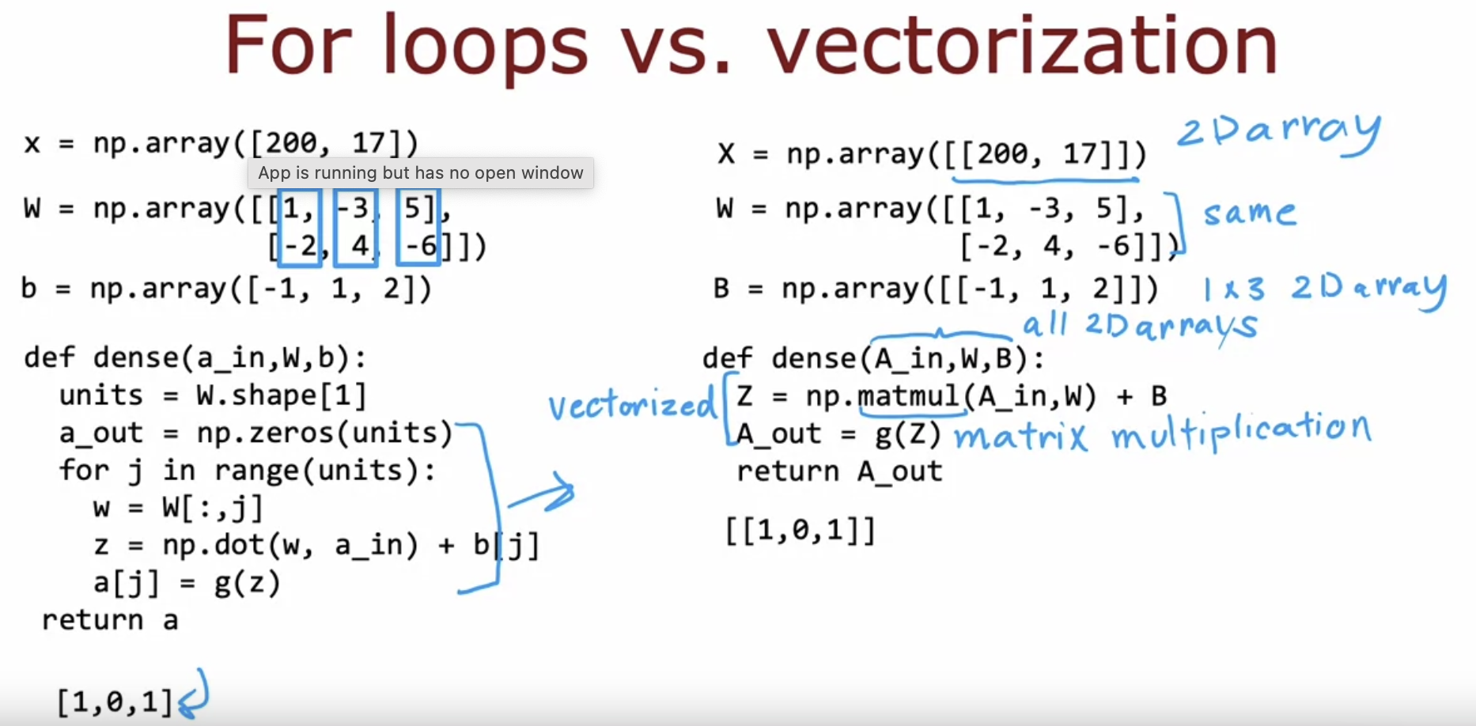

# **Matrix Multiplication**

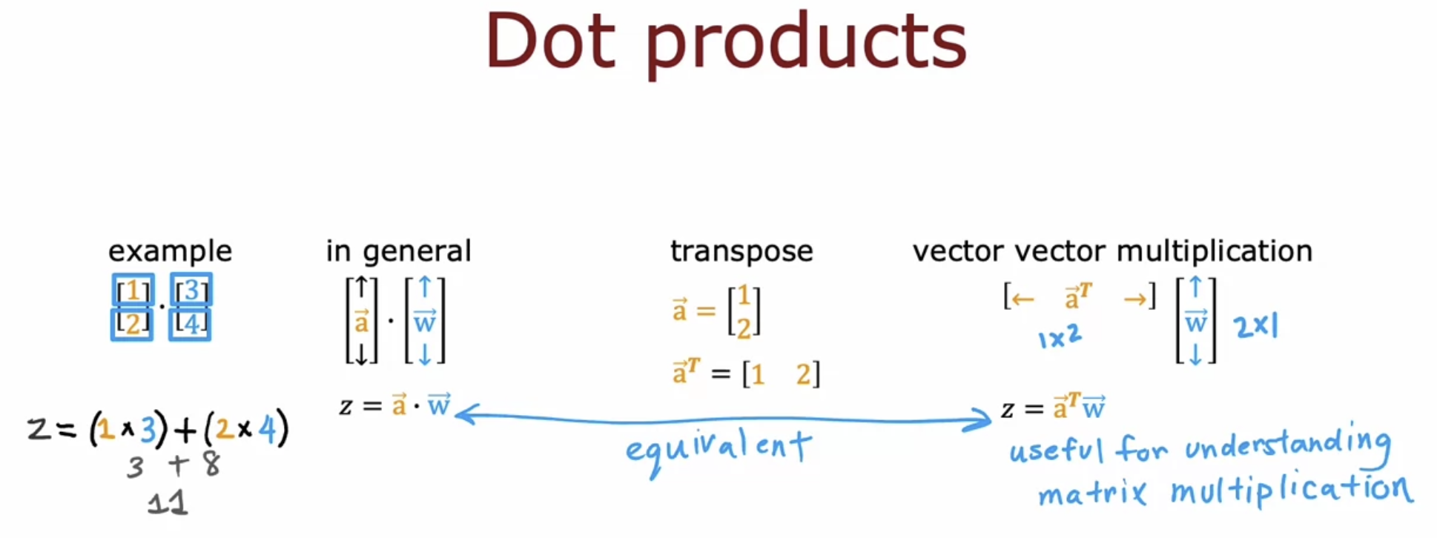  
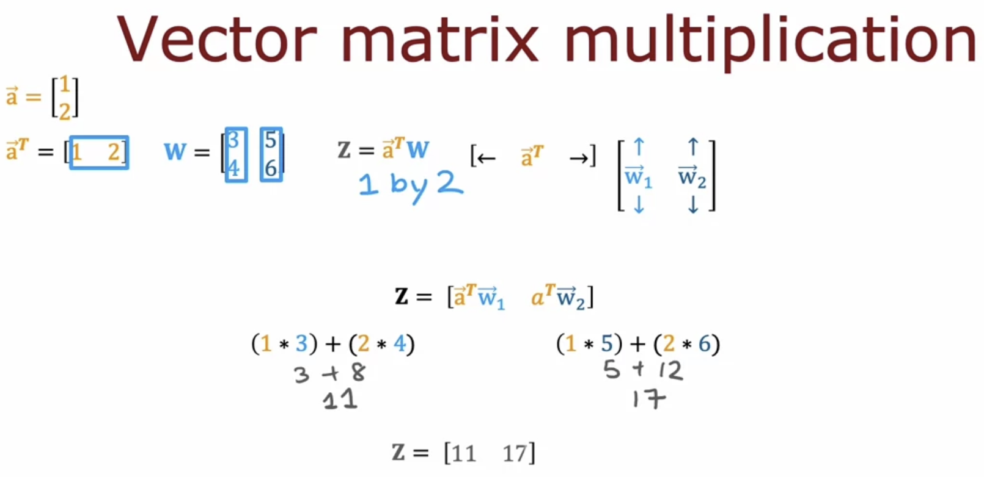

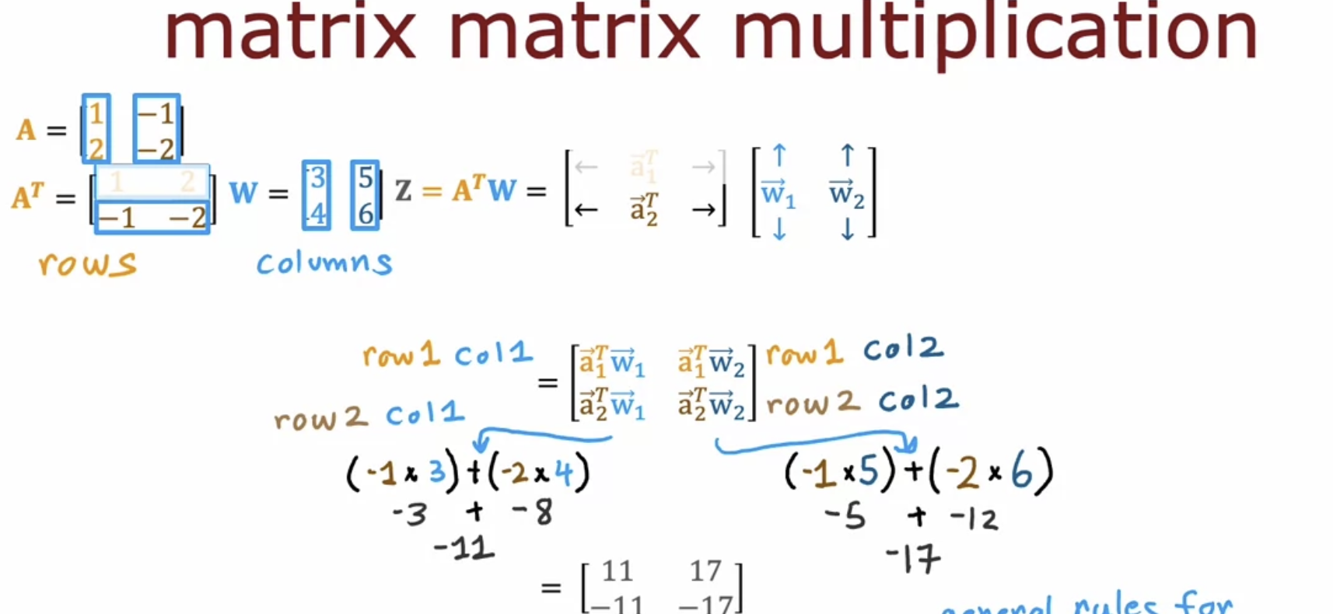

# **Matrix Multiplication**

# **Assignment**

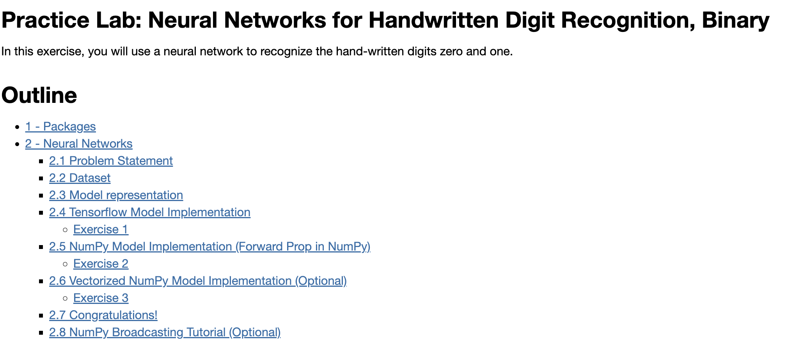

Tensor-Flow Model Implementation

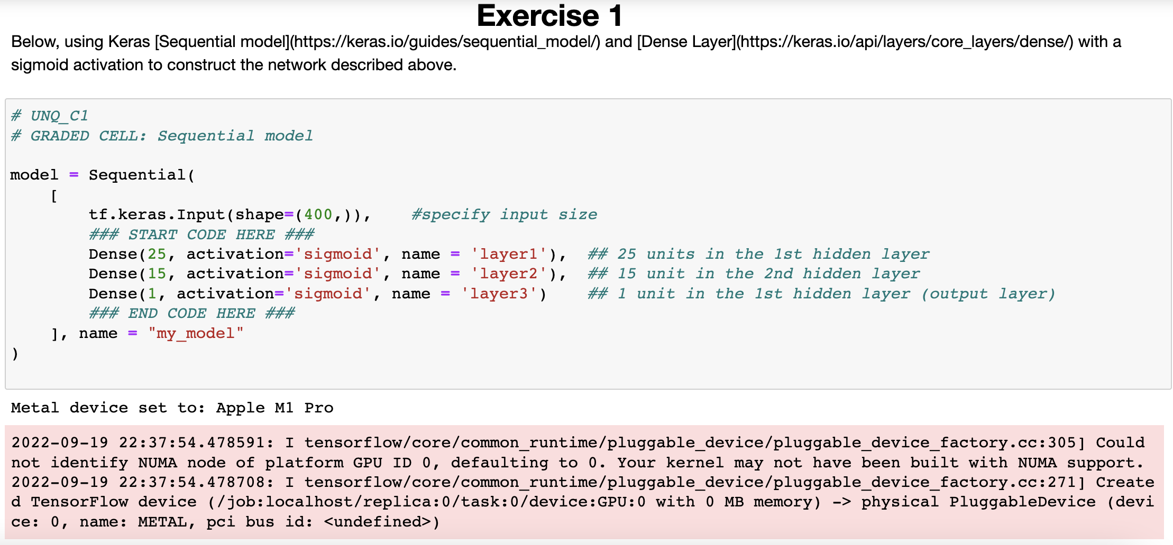

Numpy Model Implementation (Forward propagation in Numpy)

Vectorized Numpy Model Implementation (Optional)

